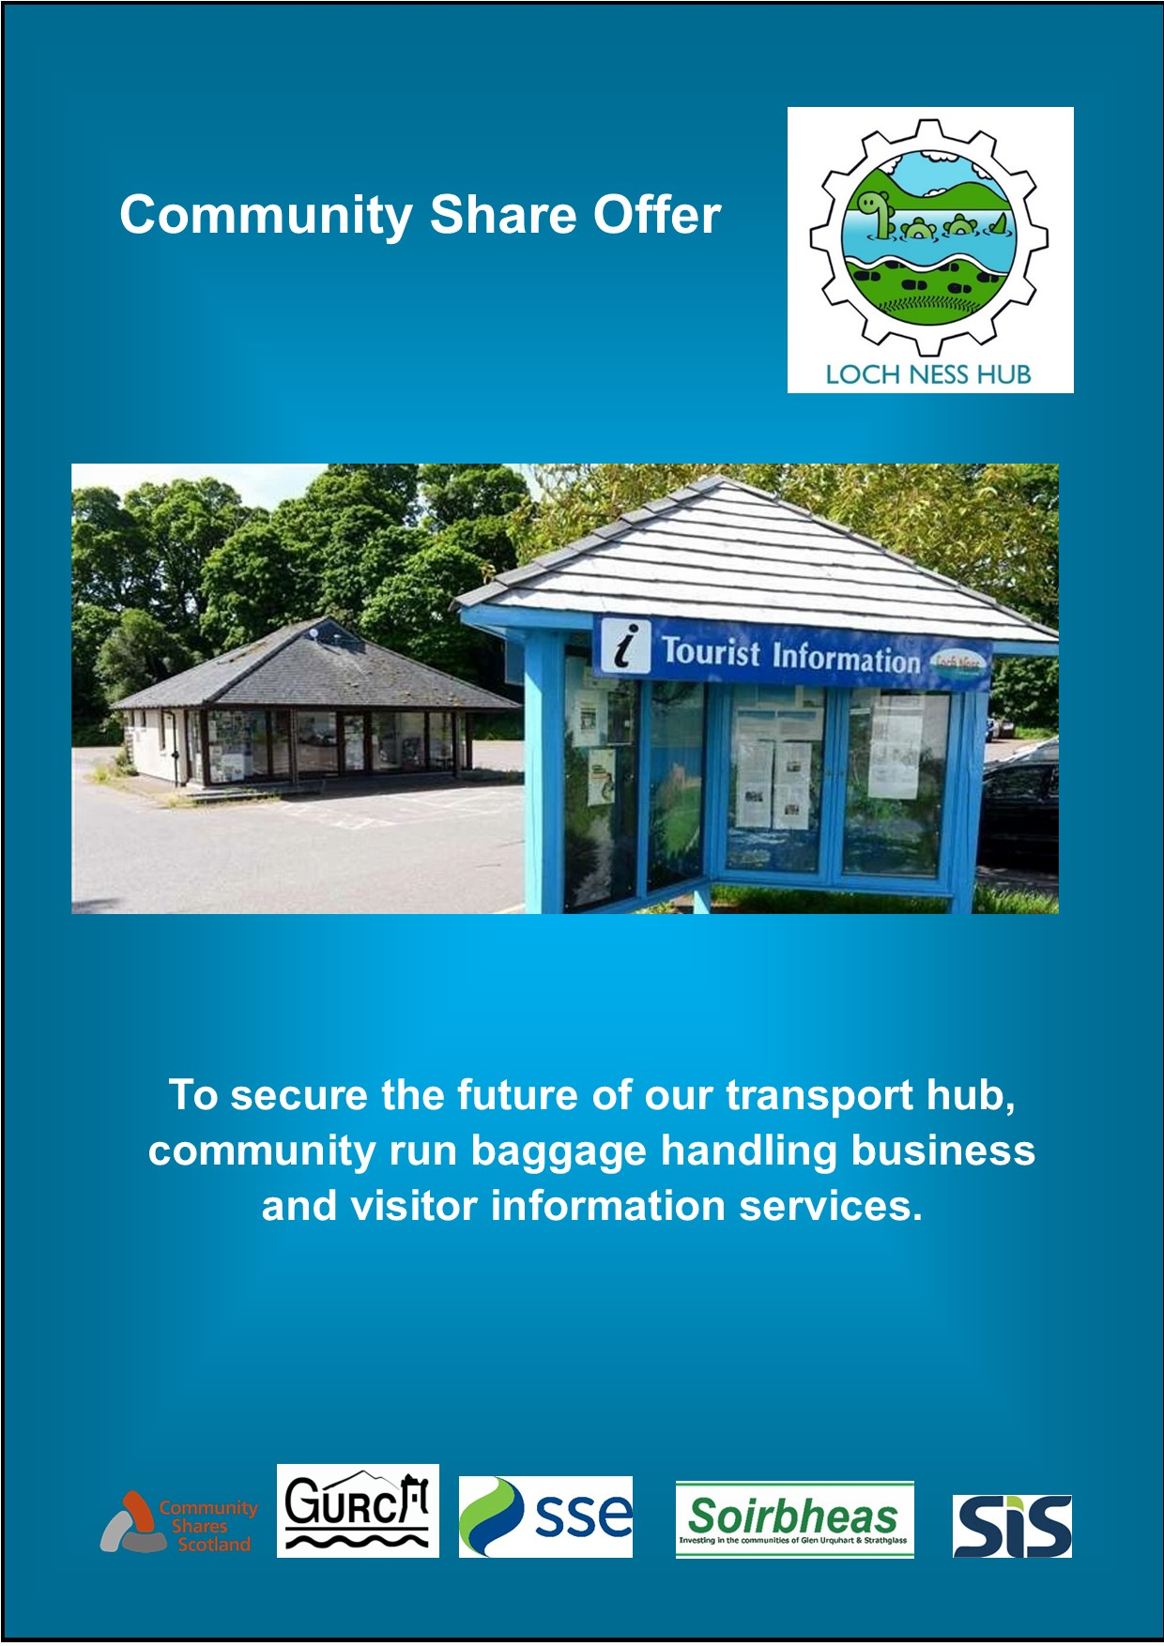

# Loch Ness Hub Community Share Offer

Aim: To secure the future of our transport hub, community run baggage handling operation and visitor information services.

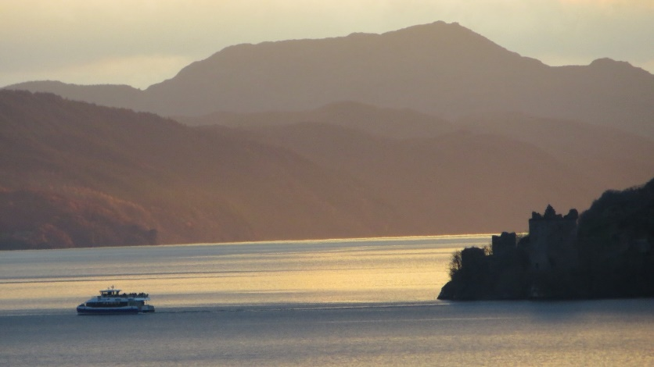

Photo by Jill Hodge

**Limited Time Offer:**  from 19th September 2020 to 17th October 2020

**Fundraising target:** £50,000 to £110,000

**Minimum investment**: £50 – **Maximum** £11,000

# Summary

The Loch Ness Hub will be a community owned and run facility, in the heart of Drumnadrochit, from which a range of services will be coordinated and managed:

* Co-ordinating local transport solutions including lift share, community vehicles and active travel routes to reduce carbon emissions and make our communities safer
* Operating a baggage transfer service for walkers using the long distance footpaths passing through our area
* Providing visitor information and supporting tourism services in the area.

This public share offer is a time limited opportunity for you, your family and friends, local businesses, groups and organisations, and any other supporters, to invest in the Loch Ness Hub, and help secure the future of our community transport hub and tourist and visitor information centre.

We have been successful in securing funds to purchase the former Tourist Information Centre in Drumnadrochit and we have also obtained funding towards the purchase of a viable local baggage transfer operation for walkers undertaking long distance routes. This will generate the income we need to support the various services the Hub will provide and allow us to employ staff and to ensure the project is a success.

To make the project a reality we need to purchase the baggage transfer operation, make improvements to the building and fit it out with equipment, and ensure we have adequate finances in place to cover initial cashflow. The total costs for this are around £220,000.

We are raising these funds through a combination of grants, a small loan and by selling shares in Loch Ness Hub Limited. Surplus profits generated by the Hub will be used to provide ongoing benefit to the community and put towards other community projects. The more we can raise through this share offer, the less we will need to borrow and the stronger a financial position the Hub will be in.

We need raise between £50,000 and £110,000, and we are looking to the people of Glen Urquhart and the wider area for support – as well as relatives, friends, and others far and wide. Everyone who buys a share becomes a member of the Society and can have their say in how it is managed going forward.

We are asking for a minimum investment of £50 (that’s 2 shares). Groups, organisations, and businesses can also invest. However, no one shareholder or organisation can buy more than 440 shares (£11,000).

The offer is available from 19th September until 17th October 2020 or when the maximum target is reached, whichever is sooner. The Board reserves the right to extend the offer beyond this initial period if they believe doing so would be of benefit.

Please invest to help us develop the Loch Ness Hub, but before you do so, it is very important that you read this share offer document. It will provide you with information about the share issue, the Society, and how the Loch Ness Hub will do business in future.

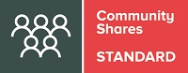

The Community Shares Standard Mark is awarded by the Community Shares Unit to offers that meet national standards of good practice.

For more information about community shares, the Standard Mark and the Unit go to: [www.communityshares.org.uk](http://www.communityshares.org.uk)

*If you are considering buying shares it is important that you read this whole document.*

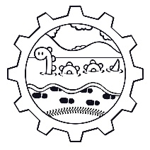

Contents

Loch Ness Hub Community Share Offer 1

Summary 1

About the Loch Ness Hub 5

What is a Community Share Offer? 5

What is the significance of the Community Anchor Share? 6

Why Invest in the Loch Ness Hub? 7

How to Buy Shares? 7

Are Shares Eligible for Tax Relief? 8

Can I Sell my Shares? 8

Financial projections 9

What Happens if we don’t Raise Enough Money from the Share Offer? 10

Who are the People Involved in Developing the Hub? 10

How to Apply 11

Application Forms 12

**Form 1– Individual** 13

**Form 2 – Buying Shares as a Gift for Someone Else** 14

**Form 3– Business, Organisation, or Other Incorporated or Unincorporated Body** 15

**Form 4 – Purchase shares as a group of family members or syndicate of friends (maximum 10 people)** 16

# About the Loch Ness Hub

In 2019, the local Development Trust, Glen Urquhart Rural Community Association (GURCA – charity no: SC 020223) made a successful bid, under the terms of the Community Empowerment Act, for a Community Asset Transfer of the former Tourist Information Centre in Drumnadrochit. The building had been owned by Highland Council and had been dormant since it was vacated by Visit Scotland in 2018. GURCA has secured the necessary funding to purchase the building, which it will own and lease to the Loch Ness Hub.

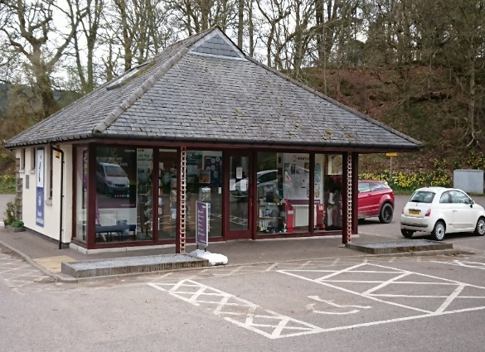The ambition to take over ownership of the building was driven by the community’s strong desire to retain a facility within the village, to provide visitor information and promote local attractions and business.

However, it was recognised from the start that the provision of visitor services would require revenue support, so there was a need to identify a business model, which could generate sufficient income to support the maintenance of the building and staffing costs. At this time, the opportunity arose to purchase Loch Ness Travel, a well-established and successful local business, which provides a baggage handling and taxi service to walkers using the long distance footpaths that pass through and close to Drumnadrochit.

In order to attract funding we needed to demonstrate that our project would provide more benefit to the community and not just to visitors. Around this time, a Transport Feasibility Study commissioned by Soirbheas, highlighted the need and demand for improved community transport and greener/low carbon travel solutions for our area. It became apparent that by working together we could create a transport hub for the community, and the former Tourist Information Centre building’s central location would make it the perfect base for the development of the Hub. Incorporating all these elements into the business model for the Loch Ness Hub means the project has greater community benefit and becomes a sustainable model.

Loch Ness Hub will lease the building from GURCA, which will be the holder of the Community Anchor Share in the business. Under the rules of the Hub any funds generated (from profits after reinvestment and interest to shareholders) will be passed to GURCA to be administered on behalf of the community.

# What is a Community Share Offer?

Community Shares are a way of raising investment capital from communities. Local people are encouraged to buy shares in the enterprise and become part-owners. As shareholders they are more likely to do everything they can to ensure the success of the business by supporting the enterprise and, in some cases, by becoming volunteers. Community shares have been used to finance shops, pubs, community buildings, local food schemes, football clubs and even renewable energy initiatives. Most community share offers are made by enterprises registered under the Co-operative and Community Benefit Societies Act 2014. This legal form provides limited liability status, just like company law. However, unlike companies, shares in these Societies are non-speculative, but democratic.

Loch Ness Hub Limited is a registered Community Benefit Society (BenCom – Registration no: 8396). Loch Ness Hub Limited has been set up to operate the baggage handling operation, provide visitor and tourist information and promote our area, and to develop and administer the various transport and travel initiatives, on behalf of the community of Drumnadrochit, Glen Urquhart and the surrounding area. If you buy shares in Loch Ness Hub you will become a member of the Society, with an equal vote regardless of the size of your shareholding. Your involvement can be as much or as little as you wish. You can vote at Member Meetings, stand for election to the Board, and volunteer skills for the running of the business.

We have developed our Society Rules (which act as our Constitution) from standard templates for Community Benefit Societies and have received guidance and support from Community Shares Scotland. Our Rules are available to view at <https://lochnesshub.com/downloads>

Community Benefit Societies are regulated by the Financial Conduct Authority. We have chosen this legal model because it emphasises the social benefit of the investment we are asking our members to make. Incorporation gives the members and Management Committee the protection of limited liability, just like a limited company, but unlike a standard limited company, a Community Benefit Society is not designed to generate private profit, but to deliver a community benefit (though every effort will be made to ensure investors will receive a fair rate of interest from their investment over the medium to long term).

This model guarantees that the assets the society will own will be used for the benefit of the community and cannot be disposed of for the private profit of the Management Committee or members.

Providing that they behave responsibly, reasonably and legally and take out necessary insurances, incorporation protects the members and Management Committee of the society from any legal action against them as individuals and eliminates any access to their personal finances in the event of the enterprise entering receivership.

*Any person or group who buys shares automatically becomes a member of the Society. Each member has one vote irrespective of how many shares they own.*

# What is the significance of the Community Anchor Share?

As holder of the Community Anchor Share, Glen Urquhart Rural Community Association (GURCA) will have certain rights:

* A certain number of reserved seats on the Loch Ness Hub Board (although it cannot have a majority of Board members)
* The ability to block changes that would fundamentally alter the nature of the Society. For certain types of resolution brought to a vote (which are set out in Rule 95 of the Society’s Rules) GURCA will be allowed a vote equivalent to 26% of the total votes cast.
* GURCA will be the recipient of surplus profits from Loch Ness Hub and will administer these in accordance with the rules of its constitution to benefit the community.

# Why Invest in the Loch Ness Hub?

The Loch Ness Hub is an exciting opportunity for our community; it gives us the chance to create a vibrant and relevant facility, providing a community Transport Hub, maintaining an information service for visitors and tourists and operating a baggage transfer service for walkers undertaking the long-distance routes in the area. We believe this will help make our community an even better place for future generations and will provide income for projects.

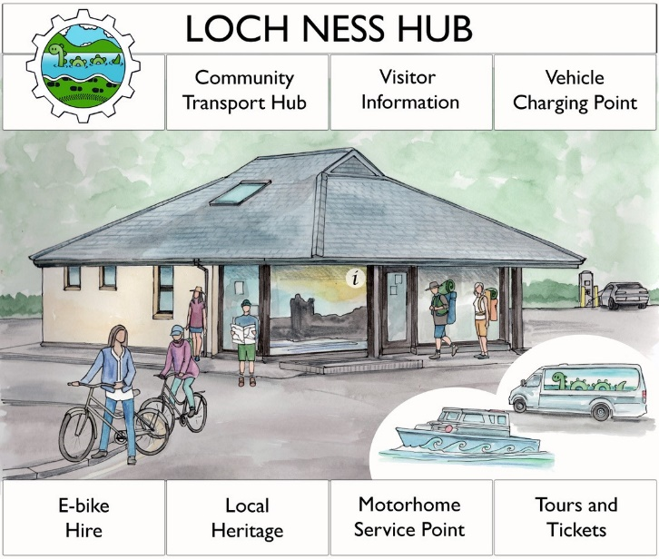One of the key aims of the Hub is to have a co-ordinated approach to address the community transports needs across our area. The ambition is to develop a number of low carbon and active travel (walking and cycling) solutions that will benefit both local people and visitors to the area. Examples of solutions are: utilisation of community owned vehicles, encouraging lift share and car share schemes, walking buses to schools, E-bike hire, EV charging points and improved path ways.

The success of this business will allow us, in due course, to pay interest to our shareholders, but just as importantly, it will allow us to pass benefits to our community, via GURCA (Glen Urquhart Rural Community Association). GURCA is what is known as the Anchor Shareholder in Loch Ness Hub, and the Society Rules set out that surplus profits will be passed to GURCA and will be used by GURCA to further community development and rural regeneration within our community area. Under the terms of clauses 4 and 7 of its constitution, GURCA must use such funds only for the benefit of the Glen Urquhart community.

There are many potential projects within our community area that could benefit from funding, and surplus profits generated from the Loch Ness Hub will be used to support a range of local projects.

The Loch Ness Hub Board will determine the sum for ‘surplus profits’, after taking into consideration how much profit from the operation will be put back into the business as required to ensure its sustainability, and how much will be passed as interest to shareholders.

A summary of the financial forecasts is available in this document and there is more detail in the Business Plan which can be found on the website <https://lochnesshub.com/downloads>. If these forecasts are accurate it is hoped that the Society will be able to start paying interest on the shares after 3 years.

# How to Buy Shares?

You need to be over 18 years to invest. Shares cost £25 each with a minimum investment of £50 (2 shares). You can buy as many as you want up to 440 (£11,000 in value). People can buy shares:

* as an individual
* as a present for someone else
* as a business, organisation, or other body
* as a syndicate (of up to 10 people)

Please fill in the appropriate application form at the back of this document (see page 11) or online at <https://lochnesshub.com/community-share-offer>

If we meet our minimum target, we will issue share certificates; if not, we will refund your money.

Membership is open to any person (whether an individual, a corporate body or the nominee of an unincorporated organisation) who completes an application for membership and is 18 years of age or over.

*If you do not wish to purchase the minimum number of 2 shares (£50) but would still like to contribute you can make a donation, but this will not entitle you to voting rights or any other shareholder benefits.*

All share applications are subject to acceptance by the Management Committee who may refuse membership at its absolute discretion.

All prospective investors are advised to read the full terms which are set out in the Society’s Rules which act as the constitution for the society. These are available from <https://lochnesshub.com/downloads>

Income will be derived from the baggage transfer services. Shareholders should expect to receive a modest return on their investment in the form of interest, with no capital growth on the share value. When the business is profitable, the shares will become interest bearing, (with an initial target rate of c.2%) and may become withdrawable after a minimum period of 3 years, subject to profitability and availability of funds.

*This share offer is not covered by the Financial Services Compensation Scheme and investors have no recourse to an ombudsman. You could lose some or all of the money you invest.*

# Are Shares Eligible for Tax Relief?

We believe that the shares in Loch Ness Hub will be eligible for tax relief under Social Investment Tax Relief (SITR) – this is a government-backed scheme designed to encourage investment in social enterprises. Loch Ness Hub is going through the process of registration for SITR, which should be complete before start of trading.

Individual UK based investors in Loch Ness Hub can apply for income tax relief after the start of trading. Your personal tax circumstances will affect the amount of tax relief in each case.

The rules for SITR tax relief require the investment to be held for at least 3 years from the start of trading (not the date of the investment). Once Loch Ness Hub has been accepted by HMRC you can apply for tax relief. Remember applications for tax relief are made by you the investor to HMRC, not by Loch Ness Hub, and so we cannot give guarantees. The Government information site [www.gov.uk/guidance/venture-capital-schemes-apply-to-use-social-investment-tax-relief](https://www.gov.uk/guidance/venture-capital-schemes-apply-to-use-social-investment-tax-relief) explains the application procedures but, if you are unsure, please seek professional advice. SITR will enable investment into Loch Ness Hub to qualify for 30% tax relief.

# Can I Sell my Shares?

In order for the Society to develop the business we will require investors to commit to keep their investment in the Society **for at least three years** before withdrawing it. After that time, they will be required to give three months’ notice of their intention to withdraw funds. Withdrawals will be paid out in the order in which the requests are received, up to a maximum total withdrawal specified for the financial year. The Society rules will give the Management Committee the power to refuse a request to withdraw funds if it would endanger the business. It is our firm intention not to use these powers unless absolutely necessary. We will endeavour to return capital to investors when requested. Once the target investment has been obtained, we hope there will be a waiting list of new members ready to replace investors who wish to withdraw funds. Whilst we anticipate that the business will become profitable and able to pay a competitive level of interest to its members, we anticipate the Society will not be able to pay any interest until trading year 2/3.

The shares that members buy are withdrawable as set out above, but they are not transferable (i.e. members shares cannot be transferred to anyone else except in the case of bankruptcy or death of the shareholder). This arrangement allows the Society to be exempt from the Financial Services and Markets Act for Society share issues.

# Financial projections

The cost of the development is projected to be £220,000 which we aim to raise through a community share offer of up to £110,000 along with £110,000 grant funding from SSE, and Soirbheas and a potential loan of up to £60,000 if required. The more we can raise from the share offer, the less we will need to borrow as illustrated below.

|  |  |  |  |
| --- | --- | --- | --- |
| **Financed by** | **A** | **B** | **C** |
| Community Shares | £50,000 | £80,000 | £110,000 |
| SSE | £80,000 | £80,000 | £80,000 |
| Soirbheas | £30,000 tbc | £30,000 tbc | £30,000 tbc |
| **SiS Loan** | **£60,000** | **£30,000** | **£0** |
| **TOTAL FUNDING** | **£220,000** | **£220,000** | **£220,00** |

Based on raising £80,000 through the share offer the Cashflow Summary below outlines the projected income and expenditure in the first 3 years.



# What Happens if we don’t Raise Enough Money from the Share Offer?

If we can’t reach the maximum community shares target of £110,000 but manage to raise £50,000 or more we still have some options:

1. The level of borrowing will be higher or we will have to seek other funding

If we fail to reach the £50,000 target then we may:

1. Further extend the period of the share offer; or
2. Close the share offer, refund everyone’s money and disband the Society.

*Please remember that by purchasing shares, you will be making a substantial contribution to establish a resilient model for our transport hub, community run baggage handling business and information services.*

# Who are the People Involved in Developing the Hub?

The group of local people organising this share offer all believe passionately in the idea of developing a community enterprise to enable the provision of the envisaged transport and information services to our community and visitors. These people are the members of Loch Ness Hub Management Committee They will be accountable to the membership and will report to them via a newsletter and an AGM.

The first members of the Society are those who signed the application for FCA registration and these members appointed the first Management Committee that will then serve until the first Annual General Meeting, which will be held no more than 18 months after the opening of the Hub. Start-up provisions require that all members of the first Management Committee will retire at the first Annual General Meeting, although they are eligible to stand for re-election.

The first Management Committee all live in Glen Urquhart but come from a wide variety of backgrounds. This team has a broad range of skills and experience to draw on, including expertise in strategic business development, budgeting, finance, marketing and other community committees. The Management Committee is supported by Soirbheas. The Committee is also in contact with advisors with experience in community assets. This is a group of people who are passionate about developing a community and visitors services and transport Hub to safeguard our community services and make our community more resilient.

**Management Committee**

Backgrounds of the management committee is available on the website <https://lochnesshub.com/meet-the-team>

* Carolyn Wilson
* Gordon Findlay
* Patricia Fearn
* Neil Barron
* Toby Stainton

# How to Apply

Apply online at <https://lochnesshub.com/community-share-offer>. If you are unable or unwilling to apply online, please read the rules below and complete the appropriate application form.

* By completing an application form the applicant offers to subscribe, on the Terms and Conditions contained in the Share Offer Document, for the value of shares specified, or such lesser number as may be accepted.
* Applicants must be 18 years of age or over, and may be requested to provide additional evidence of identity to comply with Money Laundering requirements
* An application may be made as an individual, as a business, organisation, or other incorporated or unincorporated body. An application may also be made to buy shares as a gift for someone else. Or as a family or a group of friends who wish to form a syndicate.
* **Once an application has been submitted and approved it cannot be withdrawn.**
* Multiple subscriptions will be admitted providing that they do not result in a member holding more than the maximum shares allowed of 440 (value £11,000).
* Applicants pay for shares by electronic bank transfer or cheque.

1. Make an electronic bank transfer from your online bank account (*with your name as the reference*) to Glen Urquhart Rural Community Association sort code 80-91-26, account number 00387533   
   **and either complete the form on line at** <https://lochnesshub.com/community-share-offer> **OR post the completed application form to the address below**

**OR**

1. Write out a cheque for the necessary amount made payable to ‘Glen Urquhart Rural Community Association’ and **post it, with** **the completed application form to:**

**LOCH NESS HUB SHARE OFFER, Loch Ness Hub (former TIC), The Car Park,**

**Drumnadrochit, IV63 6TX**

Please note that

* All funds will be held in a bank account in the name Glen Urquhart Rural Community Association separate from any other financial activities, until the share offer is complete.
* Applications on incomplete or inaccurate Application Forms may be accepted as if complete and accurate.
* Results of the Offer will be published on the above website and all applicants will be informed by email or post.
* If the share offer is oversubscribed and / or Loch Ness Hub is unable to offer any or all of the shares applied for, Loch Ness Hub will refund the applicant (the whole or the difference).
* An applicant who receives Shares agrees to be bound by the rules of Loch Ness Hub Ltd. These are available on the above website <https://lochnesshub.com/downloads>
* Once shares are confirmed you will be issued with a share certificate.

*This offer closes at 6pm on 17th October 2020 or whenever the maximum amount is subscribed, whichever is soonest. The Board reserves the right to extend this offer.*

# Application Forms

**Please sure you use the correct form.**

**Are you applying:**

1. For yourself, as an individual*? Use Form 1 on Page 12
2. To buy shares as a gift for someone else? Use Form 2 on Page 13
3. On behalf of a business, organisation, or other incorporated or unincorporated body? Form 3 on Page 14
4. As group of family or syndicate of friends – Form 4 on Page 15

Online forms are available at <https://lochnesshub.com/community-share-offer>

**Please note: –**

*If you are purchasing shares as a gift or in as syndicate or unincorporated organisation (sole trader) you cannot purchase shares in your own name as an individual as well.

# Application to Loch Ness Hub

## **Form 1– Individual**

I wish to become an individual member of Loch Ness Hub. In accordance with the Rules of the Society I apply for Shares to the value of £……………… (minimum £50, maximum £11,000)

**My details are:**

|  |  |
| --- | --- |
| First name: |  |
| Last name: |  |
| Address: |  |
| Post code: |  |
| Email: |  |
| Phone no: |  |

**Payment** (choose one)

⃝ I enclose a cheque made payable to Glen Urquhart Rural Community Association

⃝ I have paid via electronic bank transfer

**Make a bank transfer to our account Glen Urquhart Rural Community Association**

|  |  |  |
| --- | --- | --- |
| **Account no** | **00387533** |  |
| **Sort code** | **80-91-26** | **Please reference your payment with your surname and first initial** |

I confirm that I am 18 years old or older. **I have read the share offer document and understand and accept the terms of the share offer and the Rules of Loch Ness Hub Ltd.** I consent to Loch Ness Hub sending me, at the email address given above, formal notices or documents (or links to the Society’s website) and information relating to the management of Loch Ness Hub Ltd.

|  |  |
| --- | --- |
| Signed: |  |
| Date: |  |

This offer closes at 6pm on 17th October 2020 or whenever the maximum amount is subscribed, whichever is soonest. The Board reserves the right to extend this offer. *Completed form must be returned to* ***Loch Ness Hub Share Offer, Loch Ness Hub (former TIC), The Car Park, Drumnadrochit, IV63 6TX***

# Application to Loch Ness Hub

## **Form 2 – Buying Shares as a Gift for Someone Else**

I am applying for shares to give as a gift or gifts to one or more people. I will provide the giftee’s details to Loch Ness Hub before they issue Share Certificates. [Loch Ness Hub will ask you for the details when the offer closes]

In accordance with the Rules of the Society I apply for Shares to the value of £……………… (minimum £50, maximum £11,000) as gifts for one or more people.

**My details are:**

|  |  |
| --- | --- |
| First name: |  |
| Last name: |  |
| Address: |  |
| Post code: |  |
| Email: |  |
| Phone no: |  |

**Payment** (choose one)

⃝ I enclose a cheque made payable to Glen Urquhart Rural Community Association

⃝ I have paid via electronic bank transfer

**Make a bank transfer to our account Glen Urquhart Rural Community Association**

|  |  |  |
| --- | --- | --- |
| **Account no** | **00387533** |  |
| **Sort code** | **80-91-26** | **Please reference your payment with your surname and first initial** |

I confirm that I am 18 years old or older. **I have read the share offer document and understand and accept the terms of the share offer and the Rules of Loch Ness Hub Ltd.** I consent to Loch Ness Hub sending me, at the email address given above, formal notices or documents (or links to the Society’s website) and information relating to the management of Loch Ness Hub Ltd.

|  |  |
| --- | --- |
| Signed: |  |
| Date: |  |

*This offer closes at 6pm on 17th October 2020 or whenever the maximum amount is subscribed, whichever is soonest. The Board reserves the right to extend this offer. Completed form must be returned to* ***Loch Ness Hub Share Offer, Loch Ness Hub (former TIC), The Car Park, Drumnadrochit, IV63 6TX***

# Application to Loch Ness Hub

## **Form 3– Business, Organisation, or Other Incorporated or Unincorporated Body**

We wish to become a member of Loch Ness Hub Ltd. I understand that, as a representative of an incorporated organisation or a nominee of an unincorporated organisation (whichever is appropriate), Loch Ness Hub will require confirmation in writing of my appointment in due course.

In accordance with the Rules of the Society we are applying for Shares to the value of £……………… (minimum £50, maximum £11,000)

|  |  |  |
| --- | --- | --- |
| Organisation: |  | Type of organisation (tick one only)  Incorporated ⃝ Unincorporated ⃝ |
| Registration no:  Incorporated bodies only |
| First name: |  | |
| Last name: |  | |
| Address: |  | |
| Post code: |  | |
| Email: |  | |
| Phone no: |  | |

**Payment** (choose one)

⃝ I enclose a cheque made payable to Glen Urquhart Rural Community Association

⃝ I have paid via electronic bank transfer

**Make a bank transfer to our account Glen Urquhart Rural Community Association**

|  |  |  |
| --- | --- | --- |
| **Account no** | **00387533** |  |
| **Sort code** | **80-91-26** | **Please reference your payment with your organisations name** |

I confirm that I am 18 years old or older. **I have read the share offer document and, on behalf of my organisation, understand and accept the terms of the share offer and the Rules of Loch Ness Hub Ltd.** I consent to Loch Ness Hub sending me, at the email address given above, formal notices or documents (or links to the Society’s website) and information relating to the management of Loch Ness Hub Ltd.

|  |  |
| --- | --- |
| Signed: |  |
| Date: |  |

*This offer closes at 6pm on 17th October 2020 or whenever the maximum amount is subscribed, whichever is soonest. The Board reserves the right to extend this offer. Completed form must be returned to* ***Loch Ness Hub Share Offer, Loch Ness Hub (former TIC), The Car Park, Drumnadrochit, IV63 6TX***

# Application to Loch Ness Hub

## **Form 4 – Purchase shares as a group of family members or syndicate of friends (maximum 10 people)**

I wish to become a member of Loch Ness Hub Ltd, as the representative of up to 9 others. In accordance with the Rules of the Society we apply for Shares to the value of £……………… (minimum £50, maximum £11,000)

|  |  |
| --- | --- |
| First name: |  |
| Last name: |  |
| Address: |  |
| Post code: |  |
| Email: |  |
| Phone no: |  |

The names of the **other** people in my group/syndicate are (up to 9 others);

|  |  |  |
| --- | --- | --- |
|  |  |  |
|  |  |  |
|  |  |  |

**Payment** (choose one)

⃝ I enclose a cheque made payable to Glen Urquhart Rural Community Association

⃝ I have paid via electronic bank transfer

**Make a bank transfer to our account with the Glen Urquhart Rural Community Association**

|  |  |  |
| --- | --- | --- |
| **Account no** | **00387533** |  |
| **Sort code** | **80-91-26** | **Please reference your payment with your surname and first initial** |

I confirm that I am 18 years old or older. **I have read the share offer document and, on behalf of my organisation, understand and accept the terms of the share offer and the Rules of Loch Ness Hub Ltd.** I consent to Loch Ness Hub sending me, at the email address given above, formal notices or documents (or links to the Society’s website) and information relating to the management of Loch Ness Hub Ltd.

|  |  |
| --- | --- |
| Signed: |  |
| Date: |  |

*This offer closes at 6pm on 17th October 2020 or whenever the maximum amount is subscribed, whichever is soonest. The Board reserves the right to extend this offer. Completed form must be returned to* ***Loch Ness Hub Share Offer, Loch Ness Hub (former TIC), The Car Park, Drumnadrochit, IV63 6TX.***